# Decision Table, State Transition and Pairwise Testing

## DT

Exercise 1 – Upload Form

Consider a dialogue box which will ask the user to upload photo with certain conditions like:

* You can upload only '.jpg' format image
* File size less than 32kb
* Resolution of image 137*177.

If any of the conditions fail the system will throw corresponding error message stating the issue and if all conditions are met photo will be updated successfully.

**Solution:**

|  |  |
| --- | --- |
| **CONDITIONS** | **RULES** |

|  |  |  |  |  |  |  |  |  |
| --- | --- | --- | --- | --- | --- | --- | --- | --- |
| .Jpg format | **T** | **F** | **T** | **F** | **T** | **F** | **T** | **F** |
| Size < 32kb | **T** | **T** | **F** | **F** | **T** | **T** | **F** | **F** |
| Resol.137*177 | **T** | **T** | **T** | **T** | **F** | **F** | **F** | **F** |
| **ACTIONS** |  |  |  |  |  |  |  |  |
| Error message | **NO** | **YES** | **YES** | **YES** | **YES** | **YES** | **YES** | **YES** |
| Update photo | **YES** | **NO** | **NO** | **NO** | **NO** | **NO** | **NO** | **NO** |

Exercise 2 – Billing Cycle of Telecom Operator

Within billing system, a product sold to a customer can have following type of product charges:

* Activation Charge (**AC** € 20.00) – AC is applied on the bill for the month when product is purchased;
* Monthly Recurring Charge (**MRC** € 10.00) – MRC is applied every month after the month when product was sold;
* Cancelation Charge (**CC** € 15.00) – CC is applied on the bill on the month when product was canceled.

Each of the charges can be zero or nonzero. During monthly billing process, invoice is produced for the customer where total product charge is calculated as a sum of the three charge types (whatever charge applicable for particular month) Depending on purchase or cancelation date of the product different total product charge is applied for the customer.

**Solution:**

|  |  |
| --- | --- |
| **CONDITIONS** | **RULES** |

|  |  |  |  |  |  |  |  |  |
| --- | --- | --- | --- | --- | --- | --- | --- | --- |
| AC 20 € | Z | NZ | Z | NZ | Z | NZ | Z | NZ |
| MRC 10 € | Z | Z | NZ | NZ | Z | Z | NZ | NZ |
| CC 15 € | Z | Z | Z | Z | NZ | NZ | NZ | NZ |
| **ACTIONS** |  |  |  |  |  |  |  |  |
| TOTAL PRODUCT  CHARGE | 0 € | 20 € | 10 € | 30 € | 15 € | 35 € | 25 € | 45 € |

## ST

Exercise 1 – Credit Card on ATM

You are able to access your Bank account using credit card on the ATM (Automated teller machine) using PIN (Personal Identity Number). To be able to access the account you need to insert the Credit Card and enter your PIN. When entering correct PIN, you will have access to your Bank account. If you enter wrong PIN you will have two more attempts to reenter the PIN. After third wrong PIN attempt machine will eat your card.

**Solution:**

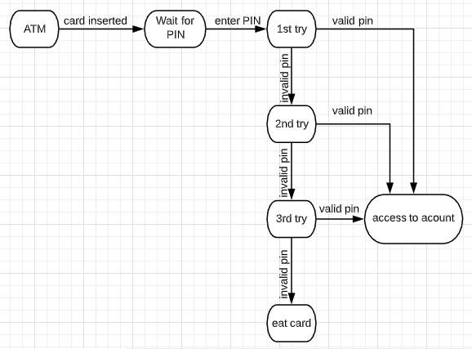

Exercise 2 – Write Test Cases

Write down the most efficient test cases based on the State Transition image below.

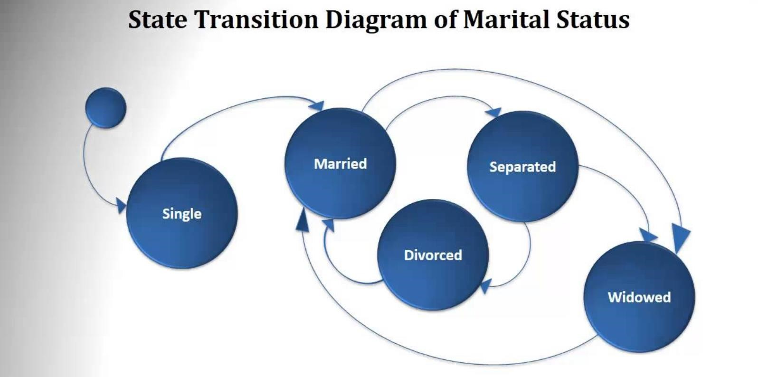

**Solution:**

**Test Case for going through all the states: Start → Single → Married → Widowed → Married → Separated → Divorced**

**Test Case for going through all the transitions: Start → Single → Married → Widowed → Married → Separated → Divorced → Married → Separated → Widowed**

## PW

Exercise 1 – Web Application Form -

An application with simple List Box with 10 elements along with a Checkbox, Radio Button and Text Box. The Constraint for the Text box is it can accept values only between 1 and 5. Below are the values that each one of the GUI objects can take:

* **List Box** – 0, 1, 2, 3, 4, 5, 6, 7, 8, 9
* **Check Box** - Checked or Unchecked
* **Radio Button** - ON or OFF
* **Text Box** - Any Value between 1 and 5

*NOTE: By using Pairwise technique, make your table in the web application we learned from the last class and generate excel file with the most efficient test scenarios.*

* **https://pairwise.teremokgames.com/**